Just Because…

32 Count 4 Wall Starter Line Dance (Newbie’s or Beginners will do this dance to Bosa Nova) Choreographed by Jo Thompson and Rita Thompson

Music: Rumba type songs. “I Just Called To Say I Love You”, “Here Lately”, “Wanna Make You Mine” all by Scooter Lee, “I Should Have Been True” by The Mavericks, “Por Ti Sere” by Ronnie Beard

CUCARACHA LEFT AND RIGHT
1-2 Rock Left foot to Left side (1), Replace weight to Right foot (2).
3-4 Step together with Left foot (3), Hold (4).
5-6 Rock Right foot to Right side (5), Replace weight to Left foot (6).
7-8 Step together with Right foot (7), Hold (8).

CUCARACHA LEFT AND RIGHT
1-2 Rock Left foot to Left side (1), Replace weight to Right foot (2).
3-4 Step together with Left foot (3), Hold (4).
5-6 Rock Right foot to Right side (5), Replace weight to Left foot (6).
7-8 Step together with Right foot (7), Hold (8).

HIPS LEFT, RIGHT, LEFT, HIPS RIGHT, LEFT, RIGHT
1 Place Left foot forward to Left front diagonal shifting hips Left.
2 Shift hips Right.
3-4 Shift hips Left putting all weight onto Left foot (3), Hold (4).
5 Place Right foot forward to Right front diagonal shifting hips Right.
6 Shift hips Left.
7-8 Shift hips Right putting all weight onto Right foot (7), Hold (8).

HIPS LEFT, RIGHT, LEFT, STEP ¼ TURN L, TOGETHER
1 Place Left foot forward to Left front diagonal shifting hips Left.
2 Shift hips Right.
3-4 Shift hips Left putting all weight onto Left foot (3),Hold (4).
5-6 Step forward with Right foot (5), Turn ¼ Left, shifting weight onto Left foot (6).
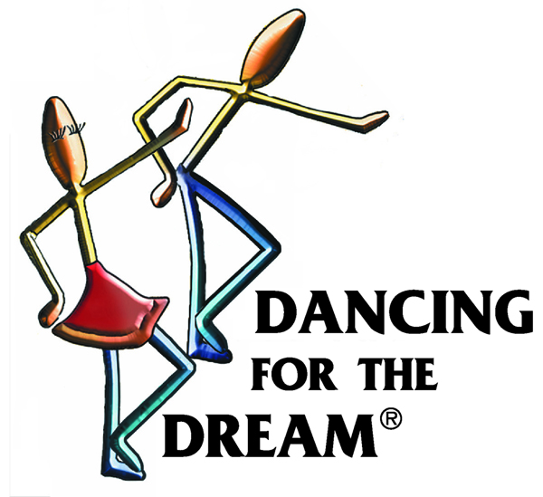
7-8 Step together with Right foot (7), Hold (8).

Start again from the beginning.

